LAB 3

OBJECTIVE: To understand the working mechanism of Layer 1 (Physical Layer) and Layer 2 (Data Link Layer) devices by creating a network topology in Cisco Packet Tracer and verifying their functions.

THEORY:
Layer 1 Device (Physical Layer)
- Examples: Hubs, Repeaters, Cables.
- Function: Transmits raw bits (0s and 1s) over the physical medium without looking at MAC or IP addresses.
- Working: A hub receives data from one port and broadcasts it to all other ports. It does not store MAC addresses.

Layer 2 Device (Data Link Layer)
- Examples: Switches, Bridges.
- Function: Works with MAC addresses to forward frames to the correct destination port.
- Working: A switch learns MAC addresses from incoming frames and stores them in a MAC Address Table, allowing direct frame delivery instead of broadcasting to all.

TOPOLOGY:
Layer 1 (Hub) Network:
- Devices: 3 end devices (PC0, Laptop0, PC5) connected via Hub0.
- IP Addresses:
- PC0 → 10.10.10.10
- Laptop0 → 10.125.130.2
- PC5 → 10.220.132.5

Layer 2 (Switch) Network:
- Devices: 3 end devices (PC6, PC7, PC8) connected via Switch0.
- IP Addresses:
- PC6 → 192.168.1.10
- PC7 → 192.168.1.11
- PC8 → 192.168.1.12

PROCEDURE:
Layer 1 Device (Hub)
- Drag and drop a Hub from the devices list in Cisco Packet Tracer.
- Connect 3 PCs to the Hub using copper straight-through cables.
- Assign different IP addresses to each PC.
- Test connectivity using the ping command.
- Observe that the Hub broadcasts data to all connected devices.

Layer 2 Device (Switch)
- Drag and drop a Switch from the devices list.
- Connect 3 PCs to the Switch using copper straight-through cables.
- Assign IP addresses in the same network.
- Ping between devices to generate traffic.
- On the switch, enter the following commands:

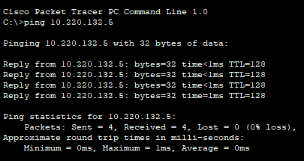
Layer 1, ping command to test the connection
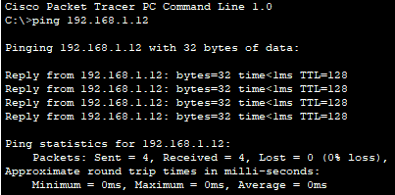
Layer 2, ping command to test the connection

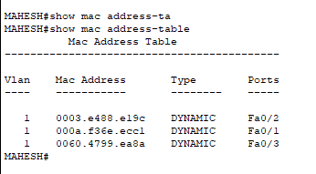
Layer 2, MAC address-table in SWITCH

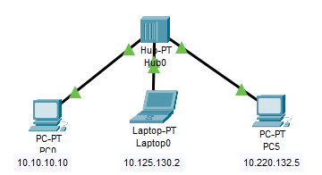
HUB connection (Layer 1)

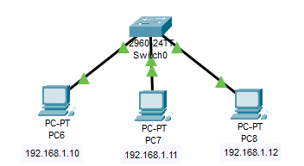
SWITCH connection (Layer 2)

RESULTS:
The program successfully demonstrates process creation using the fork() system call. A parent process creates a child process, waits for it to finish, and then exits.

CONCLUSION:
This lab provided hands-on experience with process management in OS, particularly using the fork() system call. It showed how processes are created and how a parent can manage child execution using wait().

